Test Link Setup

Version – 1.8

Prerequisite:-
MySql
PHP
Web Server (IIS)

Installation of MySql:-
- Double Click on the mysql-essential-6.0.3-alpha-win32.msi and follow the instructions:-
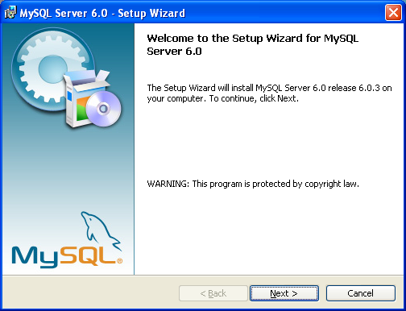

- Click on the Next button.

- Click on the Next button.
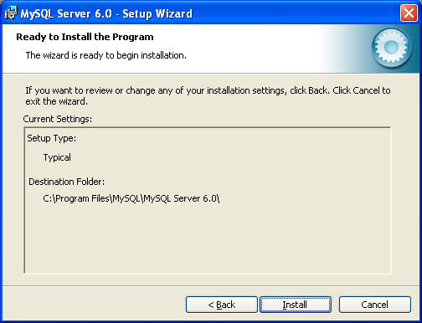

- Click on the Install button.
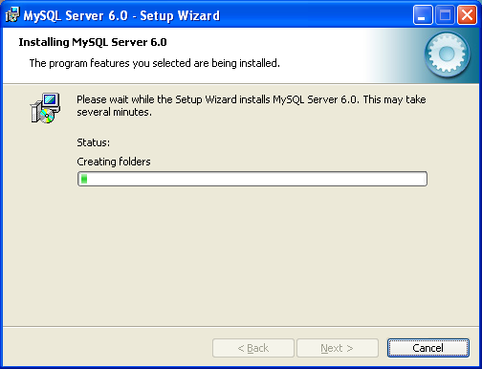

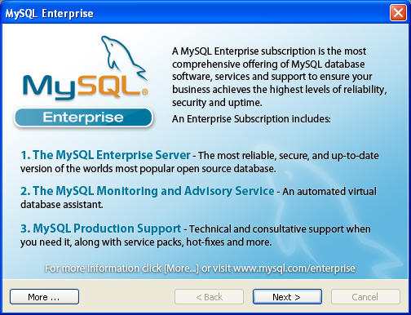

- Click on the Next button.
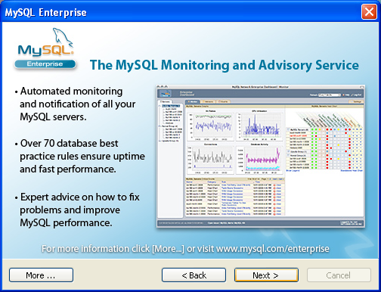

- Click on the Next button.
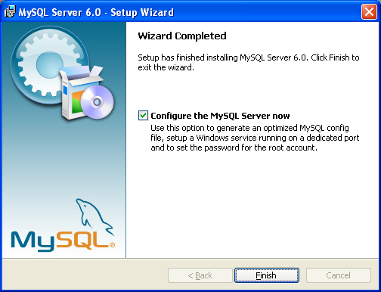

- Click on the Finish button.
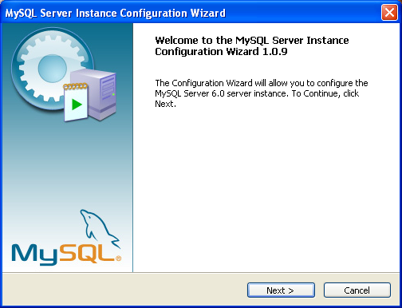

- Click on the Next button.
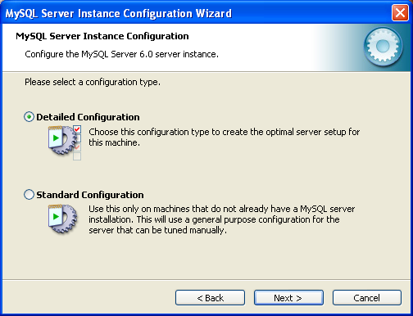

- Click on the Next button.
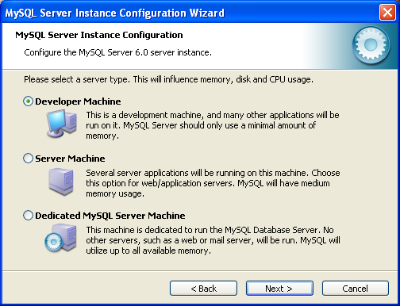

- Click on the Next button.
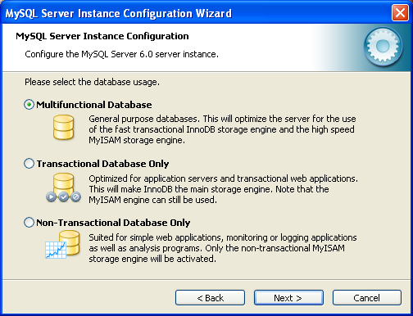

- Click on the Next button.
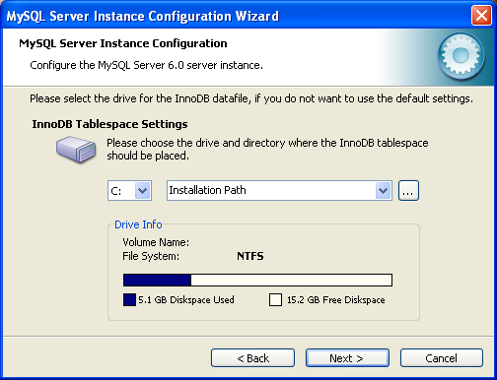

- Click on the Next button.
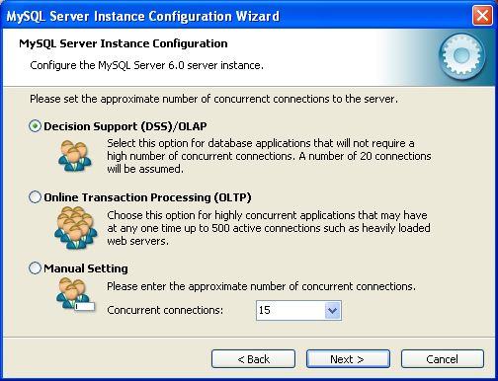

- Click on the Next button.
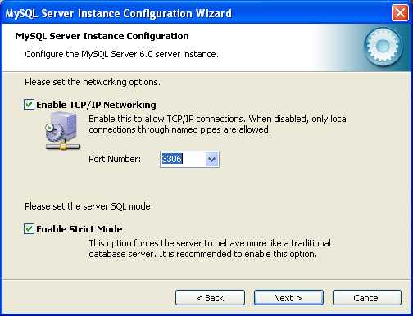

- Click on the Next button.
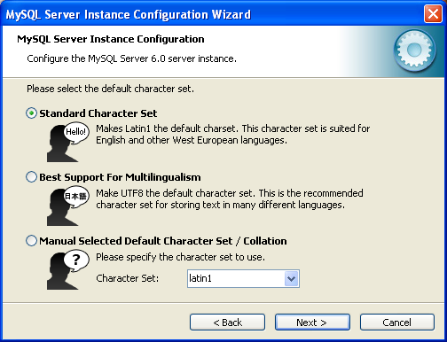

- Click on the Next button.
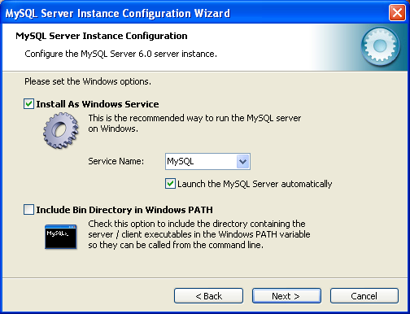

- Click on the Next button.
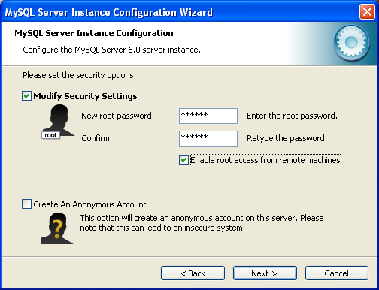

- Enter the password and Click on the Next button.
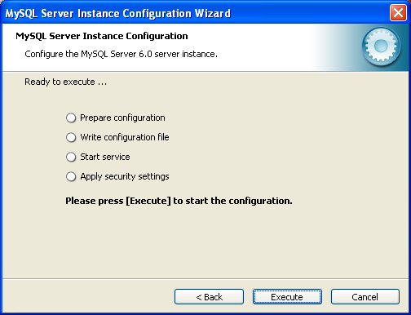

- Click on the Next button.
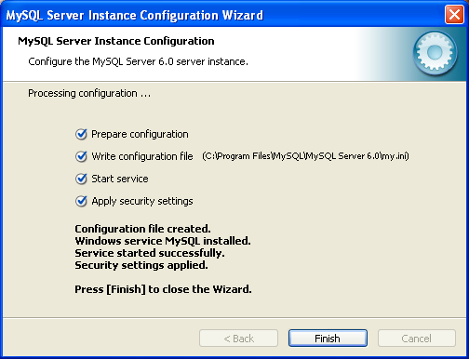

- Click on the Next button.

Installation and Configuration of PHP:-
- Download php-5.2.5-Win32.zip and php-5.2.5-win32-installer.msi
- Double click on the php-5.2.5-win32-installer.msi
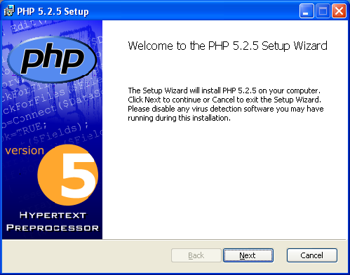

- Click on Next button.
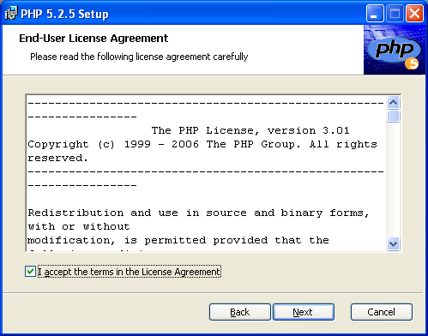

- Click on Next button.
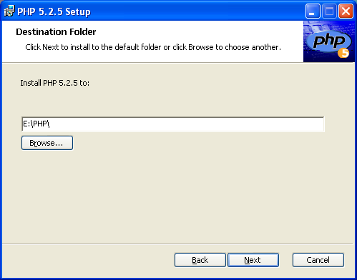

- Click on Next button.
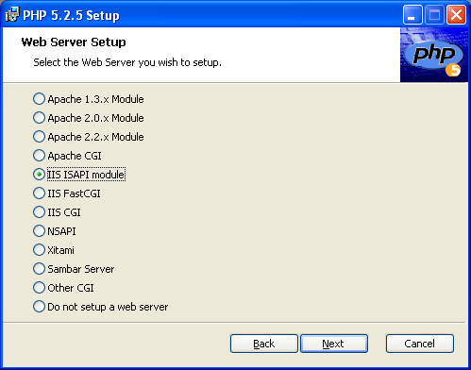

- Click on Next button.
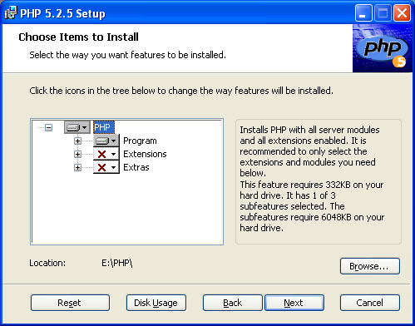

- Click on Next button.
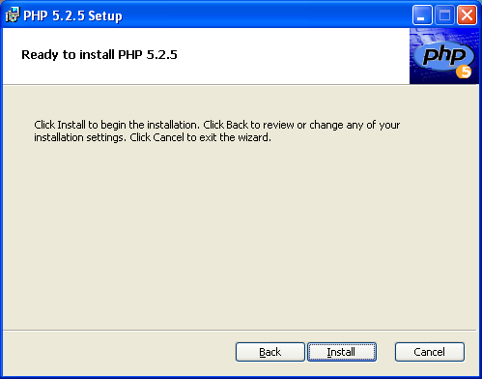

- Click on Install button.
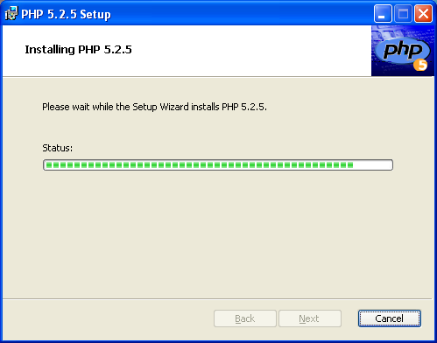

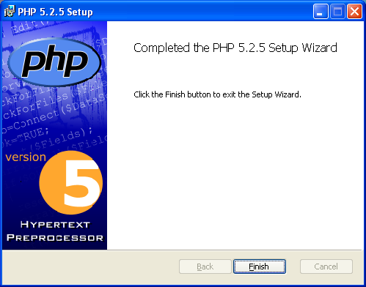

- Click on Finish button.
- Extract the php-5.2.5-Win32.zip file into a directory. It will create a directory php-5.2.5-Win32.
- Copy all the files and directory from php-5.2.5-Win32 and paste into the PHP installation folder.
- Look for php.ini under PHP directory and delete it".
- Look for php.ini_dist and rename it with php.ini. Open this file with Notepad.
- Uncomment the line extension=php_mysql.dll and extension=php_mysqli.dll (around line 650) in your php.ini file.
- Give the extension directory path as C:\PHP\ext\
- Copy this php.ini into C:\windows folder
- Go to the Start->Run. Type the "inetmgr" and click on OK. Expand the Web Sites-> Default Web Site directory.
- Under Default Web Site directory, right click on TestLink directory and select Properties.
- Go to the Directory Security tab. Click on Edit button under "Anonymous access and authentication control "option.
- Unchecked the Anonymous check box. Check the Integrated Windows Authentication check box. Click on OK button.
- Restart the IIS services and access the Test Link.

TestLink 1.8 Installation

- Download Testlink 1.8 from http://sourceforge.net/project/showfiles.php?group_id=90976&package_id=270236 site.
- Extract all the files from testlink_1.8.RC1.zip file.
- Rename the directory “testlink_18RC1” to “testlink”.
- Open the Internet Explorer and navigate the link “http://localhost/testlink/install/index.php”.
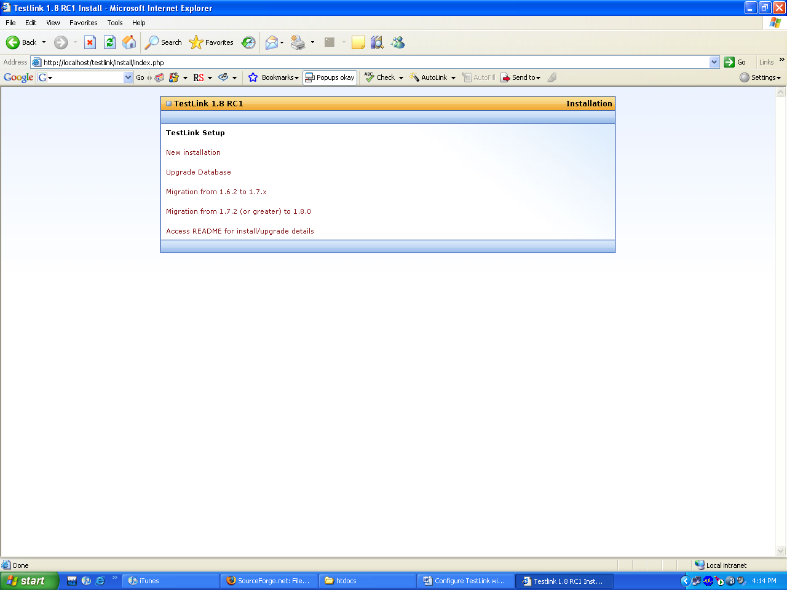

- Click on the New Installation link.
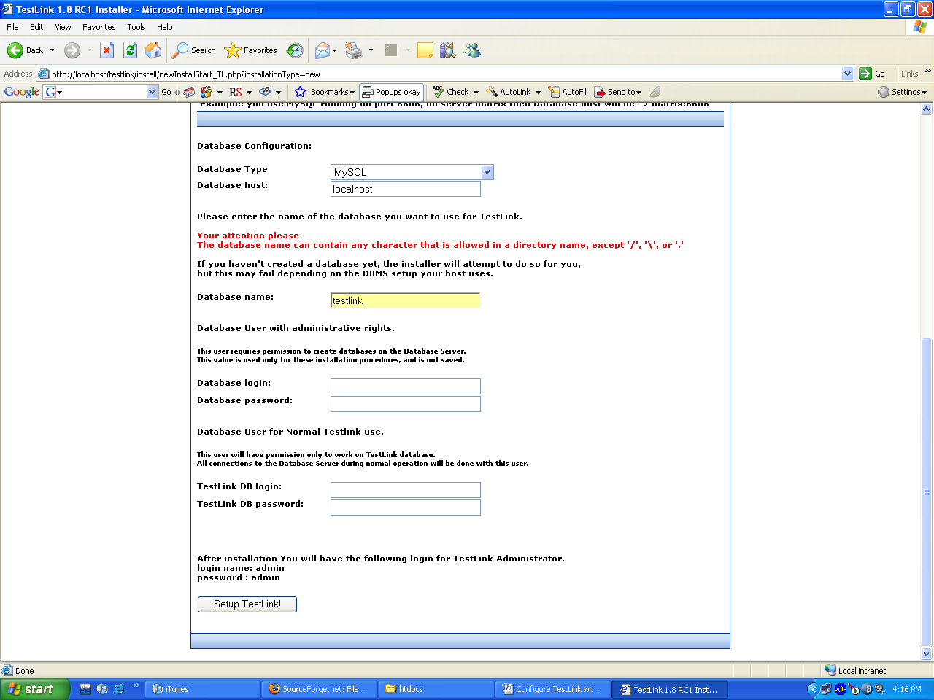

- Enter the TestLink database name. Enter the database username or password. Enter the TestLink username and password. Click on Setup TestLink button.
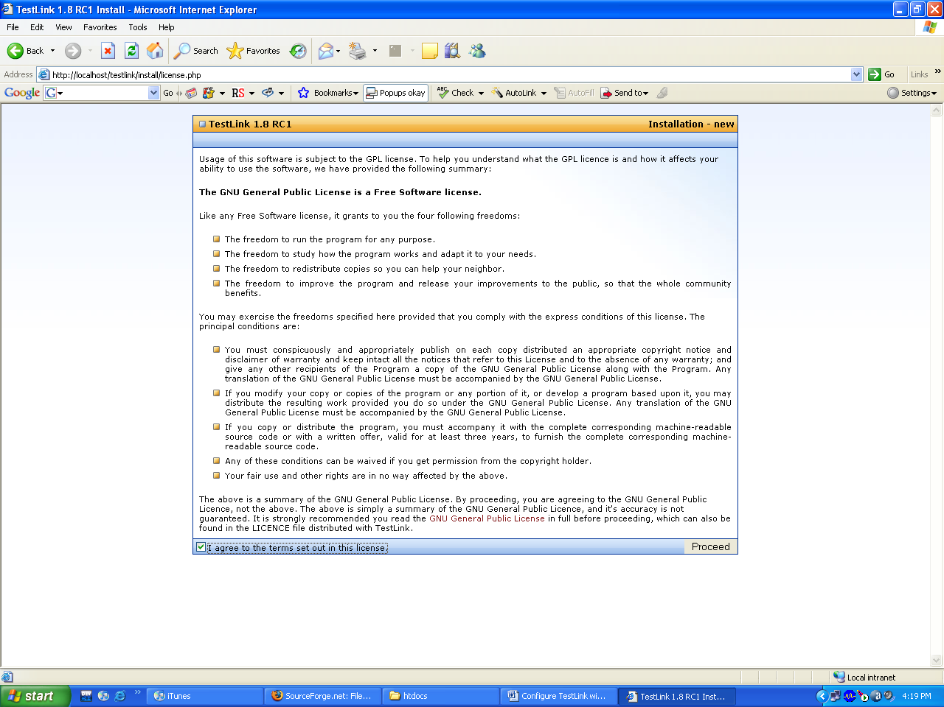

7) Accept the license agreement. Click on Proceed button.

